**Preprocessing Techniques:**

* **Managing Missing Values**
* Count the nulls found in each column of the data frame. After calculating it was found out that columns:
  + **Subtitle** contains nullswith more than 70% percent
  + **In-app purchase** contains nulls with about 39% percent
  + **Language** contains nulls with about 0.2%

**Implementation:** data.isnull().sum().sort_values(ascending=False)

* To Handle these Columns:
  + **Subtitle** and **In-app** **purchase** were dropped as columns, As filling the missing values with imaginary values would affect the accuracy of the model.

**Implementation:**

data.drop(['Subtitle','In-app Purchases'],axis=1,inplace=True)

* + The nullsin **Language** would be filled with the mode value of this column as it was found out during analysis that the data was skewed.

**Implementation:**

data['Languages'].fillna(data['Languages'].mode()[0], inplace=

True)

* **Managing Unique Values**
* Checking if the columns containing unique values

**Implementation:**

data['ColumnName'].is_unique

* Dropping unique columns as they won’t affect the decision taken to predict values of average rating

**Implementation:**

data.drop(['URL','Icon URL','Name','ID'],axis=1,inplace=True)

* **Date Handling**
* Converting date columns **Original Release Date, Current Version Release Date** from dtype object to int64 by making type first as datetime64

**Implementation:**

data['Original Release Date']=pd.to_datetime(data['Original Release Date'],dayfirst=True).astype('datetime64[ns]').astype('int64')

data['Current Version Release Date'] = pd.to_datetime(data['Current Version Release Date'],dayfirst=True).astype('datetime64[ns]').astype('int64')

* **Managing Categorical Columns**
* Using ANOVA technique to test correlation between the categorical columns are **Primary Genre, Genres, Developer, Languages** and numerical column **Average User Rating**

**Implementation:**

import statsmodels.api as sm

from statsmodels.formula.api import ols

model = ols('Rating ~ Developer', data=data).fit()

sm.stats.anova_lm(model, typ=2)

model = ols('Rating ~ Primary', data=data).fit()

sm.stats.anova_lm(model, typ=2)

model = ols('Rating ~ Languages', data=data).fit()

sm.stats.anova_lm(model, typ=2)

model = ols('Rating ~ Genres', data=data).fit()

sm.stats.anova_lm(model, typ=2)

* + **Language:** The result of ANNOVA was greater than 0.5 so the column was dropped.

**Implementation:**

data.drop(['Languages'],axis=1,inplace=True)

* + **Primary Genre** & **Genres** & **Developer:** The result of ANNOVA was less than 0.5 so One Hot Encoding Technique was used and dropping those columns to be replaced by their values.

**Implementation:**

dumies1=pd.get_dummies(data['Developer'])

dumies2=pd.get_dummies(data['Primary Genre'])

dumies3=data['Genres'].str.get_dummies(sep=",")

data=data.drop(['Developer'],axis=1)

data=data.drop(['Primary Genre'],axis=1)

data=data.drop(['Genres'],axis=1)

data=pd.concat([data,dumies1],axis='columns')

data=pd.concat([data,dumies2],axis='columns')

data=pd.concat([data,dumies3],axis='columns')

* **Age Rating** a categorical column with numeric values so the ‘+’ was removed by replacing it with empty string then converting it into numeric values.

**Implementation:**

data['Age Rating']=data['Age Rating'].str.replace('+', '')

data['Age Rating']=data['Age Rating'].apply(pd.to_numeric)

* **Anomaly Detection** 
  + Using the Isolation Forest Algorithm to detect anomalies by predicting if the sample is an anomaly or not, Then dropping the anomaly ones.

**Implementation:**

from sklearn.ensemble import IsolationForest

model_IF = IsolationForest(contamination=float(0.1))

model_IF.fit(train_data)

data_without_outliers=train_data.loc[train_data['anomaly']!=-1]

X_train=data_without_outliers.drop(['Average User Rating','anomaly'],axis=1)

* **Normalizing**
  + By using StandardScaler function that removes the mean and scales each feature/variable to unit variance.

**Implementation:**

from sklearn.preprocessing import StandardScaler

sc = StandardScaler()

X_train_std = sc.fit_transform(X_train)

X_test_std = sc.transform(X_test)

**Analysis:**

* By getting the count plot for the target column **Average user rating** it was found out that data skewed to the left and the maximum **Average user rating** found is 4.5

* Analysis was made on the four categories in **Age rating** column with the target column **Average user rating** was found that the distribution of the data was the same in all different category

* 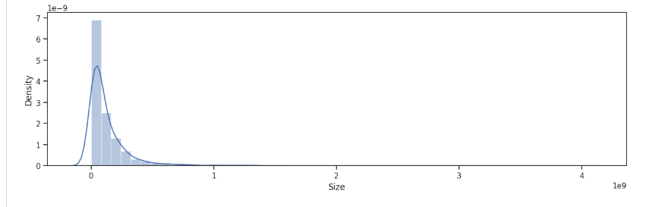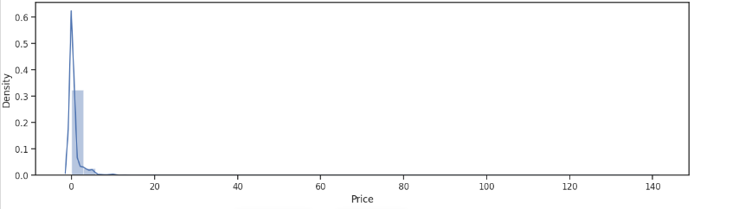 By getting the density for the two columns **Size and Price**  it was found that most of the values are zeroes
* By getting four different quantiles for **size** column it was found out that the distribution of the data was the same in all of them , left skewed with maximum **Average user rating** value 4.5

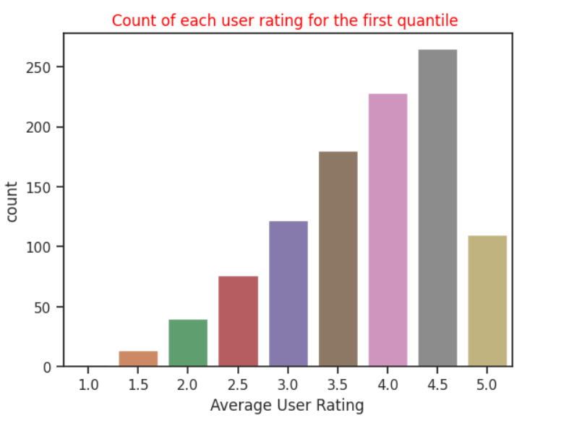

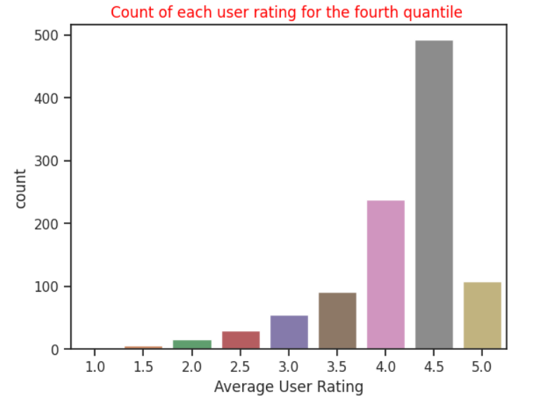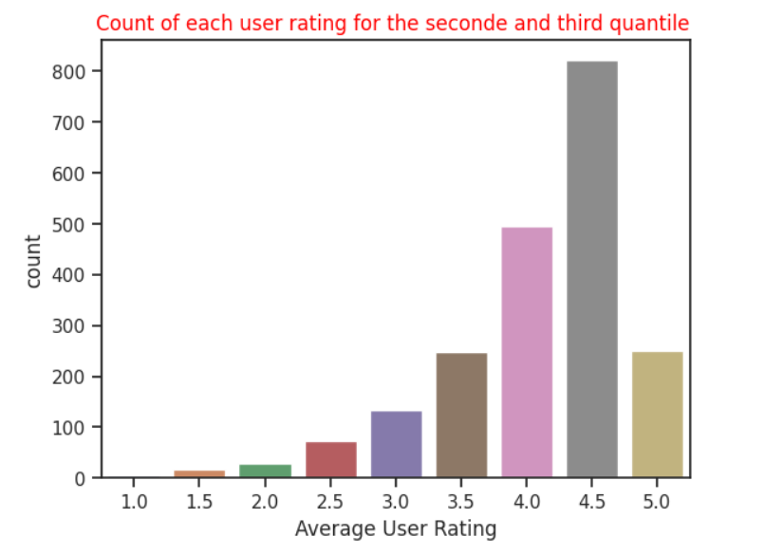 🡺 We checked how would the **Average user rating** be affected if the value of the price column increases ,it was found out that directly proportional as the price increases the **Average user rating** tends to increasebut as the number of entries with the price more than ten is low **(12 entry)** so this 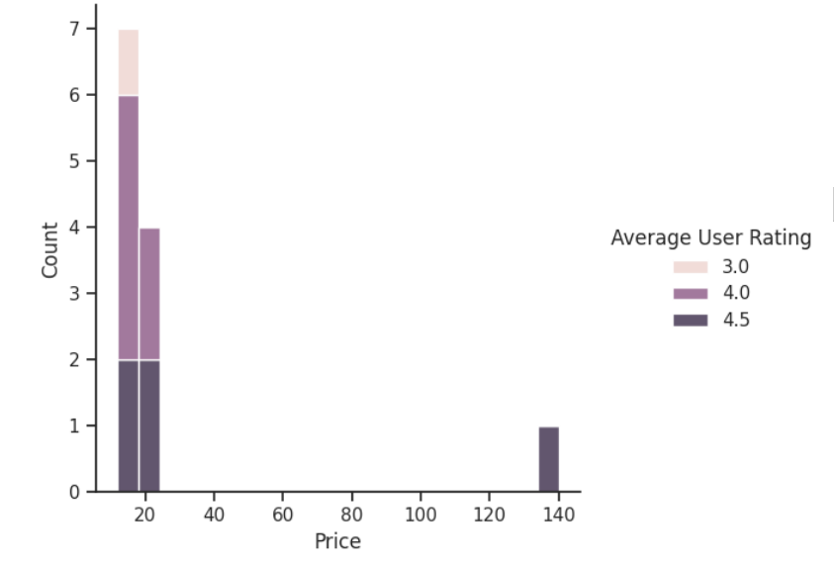rows does not affect the target column

* Analysis was made on **Primary genre** values (except game).

Many values was detected to be an outlier

**Regression Techniques:**

* XGB:

A series of weak learners (usually decision trees) are trained sequentially to iteratively improve the accuracy of the final model. Each weak learner is trained on the residual errors from the previous tree, so that the next tree can focus on the errors that the previous trees were unable to capture.

* Lasso Regression

A linear regression technique that helps to prevent overfitting by adding a penalty term to the cost function. The penalty term is proportional to the absolute values of the coefficients of the regression model, which encourages some of the coefficients to be exactly zero. This can be useful for selecting important features and reducing the complexity of the model

* Linear Regression

Linear regression is a statistical method used to model the relationship between a dependent variable (y) and one or more independent variables (x). The goal of linear regression is to find the "best fit" line that describes the linear relationship between the variables.

* Decision Tree

A decision tree works by recursively splitting the data into subsets based on the values of the input variables until a decision can be made about the value of the target variable.

At each node of the decision tree, the algorithm evaluates a condition based on one of the input variables and splits the data into two or more subsets based on the outcome of the condition. This process is repeated for each subset, creating a branching structure as the tree grows.

* Random Forest

A random forest consists of a large number of decision trees, each of which is constructed using a random subset of the original data and a random subset of the input features. The trees are built independently and their predictions are combined to make the final prediction.

At each node of the tree, the algorithm selects the best feature to split the data based on criteria such as information gain or Gini impurity. However, in random forest, the selection of the feature is limited to a random subset of the original features. This creates diversity among the trees and reduces overfitting, as each tree has its own biases and errors.

* SVR

The algorithm works by finding the best hyperplane that fits the data, while minimizing the distance between the predicted values and the true values.

In SVR, the hyperplane is represented by a function that takes the input features as input and outputs the predicted value. The function is constructed using a subset of the training data, called support vectors, that are closest to the hyperplane.

**Difference between models:**

* **Linear regression and SVR**
* Handling non-linear relationship:

**linear regression** assumes a linear relationship between the input features and output variable can’t handle non-linearity while **SVR** can handle non-linearity using kernel functions

* Goal:

**linear regression** aim to minimize the sum of MSE while **SVR** aim to find hyperplane with maximum margin

* Overfitting:

**linear regression** suffers from overfitting when the number of feature is large while **SVR** can handle high dimensional dataset with good generalization due to regularization techniques

* **Linear regression and XGBoost**
* Handling non-linear relationship:

**linear regression** assumes a linear relationship between the input features and output variable can’t handle non-linearity while **XGB** can handle non-linearity using decision trees

* Ways of learning:

**linear regression i**s a single model learn with fixed coefficients while **XGB** is an ensemble learning combine multiple decision trees

* Regularization:

Must apply regularization technique on **linear** **regression** while **XGB** includes built in regularization techniques

* Feature Importance:

**XGB** providesfeatureimportance score that rank importance of each input feature while linear regression not

**RESULTS:**

* **Errors**
  + **Linear regression:** 0.5159922923602814
  + **XGB:** 0.4364058167245837
  + **SVR:** 0.4676278131452984

**Features:**

* **Used:**

Developer, Primary Genre, Genres, Original Release Date, Current Version Release Date.

* **Discarded:**

URL, ID, Name, Subtitle, Icon URL, User Rating Count, Price, In-app Purchases, Description, Age Rating Languages, Size.

**Size:**

The data was split into 80% training and 20% testing where the number of entries used in training was 3731 entry while testing was 1043 entry.

**Improvement:**

* Grid Search technique was used for improvement as it creates grid of all possible combinations of the model hyperparameters values then train the model with each combination.
* Techniques with built in regularization (**Lasso, XGB, SVR**) were used instead of **linear** **regression** that doesn’t apply regularization.

**Conclusion:**

* The best models that were concluded are **XGB** and **SVR** as they deal with non-Linearity. And the dataset used was found to be non-Linear.
* It was intuited that the linear regression model wasn’t said to be the best as the linear regression doesn’t handle nonlinear features and it was proved as the error of the model was the greatest of all models
* It was intuited that features as URL, ID, Name, Icon URL are unique features and was proved by checking them using the is_unique function.
* It was intuited that Price and Size features would affect the predicted target feature but it was disproved during analysis